**Business Development Report: Upliance.ai Cooking Assistant**

**Summary:**

This report delves into the performance of Upliance.ai's Cooking Assistant by analysing key metrics such as revenue, user engagement, dish popularity, and demographic trends. By focusing on user behaviour, order trends, and session data, we provide actionable recommendations to enhance operational efficiency, optimize revenue streams, and increase user engagement

**Key Insights: From Data to Opportunity**

* **Revenue Breakthroughs:** The total revenue from 16 cooking sessions and 16 orders amounted to $180.00, with the average order value being $11.25. This suggests steady engagement, though there's room to improve order volume and average revenue per user.

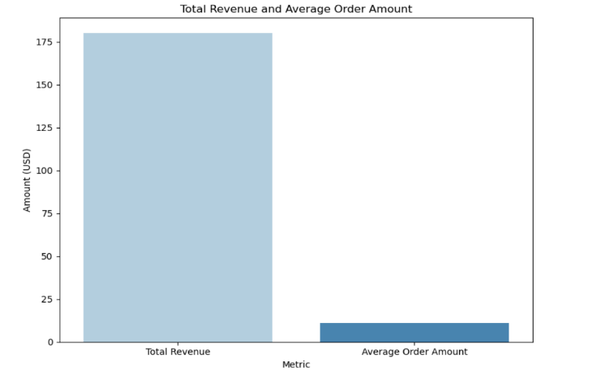

* **User Engagement Metrics:** The link between cooking sessions and order placement is clear users who participated in cooking sessions were more likely to place additional orders. The order completion rate stands at 87.5%, and the average session rating is 4.5/5, suggesting that customers are highly satisfied with their experience.

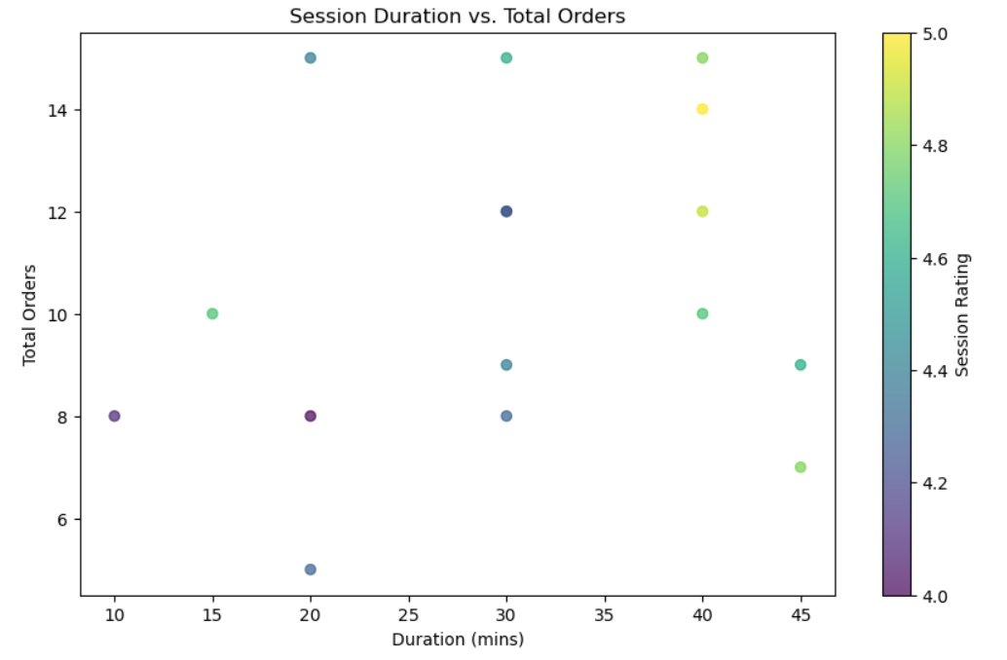

* **Top Performers:** The dishes that attract the most orders and contribute to overall revenue are Spaghetti, Caesar Salad, and Grilled Chicken. These popular items are vital to understanding user preferences and planning future offerings.

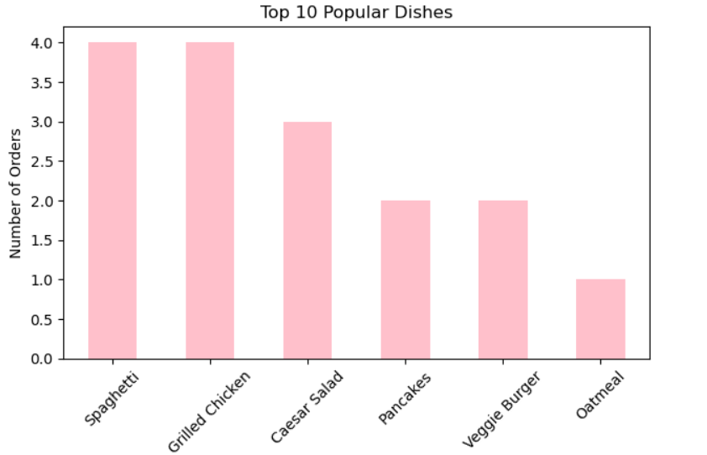

* **Demographic Powerhouses:** The 25-34 age group stands out as the most engaged, displaying higher activity in both cooking sessions and orders. This age group’s preferences, along with their greater engagement, make it an ideal target for focused marketing efforts.

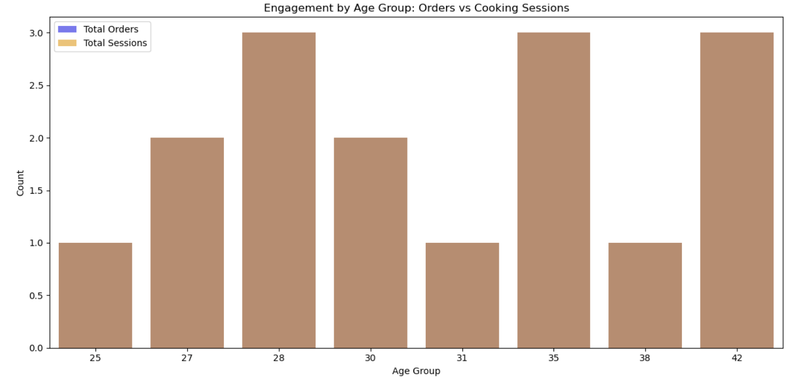

* **Operational Performance**: Cooking sessions tend to last around 30 minutes. Users who spend more time in cooking sessions generally rate them higher. However, 12.5% of orders are cancelled, with the Veggie Burger (50%) and Grilled Chicken (30%) being the highest offenders in terms of cancellations.

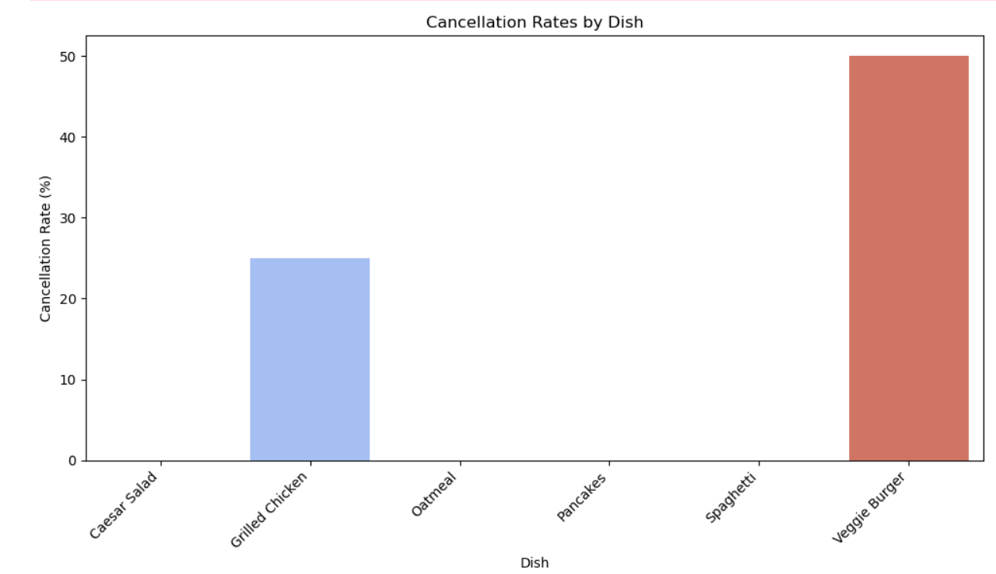

**Strategic Growth Areas: Maximizing Untapped Potential Revolutionizing High-Impact Meals:**

* Focus marketing efforts on Spaghetti, Caesar Salad, and Grilled Chicken, but address the high cancellation rates for Grilled Chicken (30%) and Veggie Burger (50%).
* Analyse the reasons for cancellations, especially for the Veggie Burger, and optimize cooking times or customer satisfaction. If delays or preparation issues are causing cancellations, these should be resolved.
* Offer promotions and bundle deals for the most popular dishes to increase sales while addressing any operational inefficiencies.

**Demographic Goldmine:**

* Continue focusing on the **25–34 age group**, which has shown higher engagement and order frequency. Consider offering tailored meal kits and recipes that appeal to this demographic.

**Boosting Engagement During Off-Peak Hours:**

* To increase engagement during non-peak hours, focus on both breakfast and lunch. For breakfast, offer quick, simple recipes that require minimal preparation and promote early-bird discounts and meal bundles, such as pairing smoothies with breakfast sandwiches. Similarly, for lunch, introduce easy-to-make recipes and offer lunch-specific bundles, like a Caesar salad with a grilled chicken wrap. Implement targeted campaigns with time-sensitive promotions and loyalty rewards during peak lunch hours, and consider offering subscription-based meal plans to encourage repeat orders. These strategies will help drive higher engagement and revenue during both breakfast and lunch periods.Bottom of Form

**Reduce Order Cancellations**:

* Investigate why Grilled Chicken and Veggie Burger have high cancellation rates. For Grilled Chicken (30%) and Veggie Burger (50%), review preparation times and overall customer satisfaction.
* Improve communication with customers about dish availability and expected delivery times. Consider introducing an option for customers to view real-time cooking progress.

**Expansion to Underserved Markets:**

* Urban regions are performing well, but there is significant potential in rural areas. Offer discounts, promotions, and free delivery in rural markets to attract new customers. 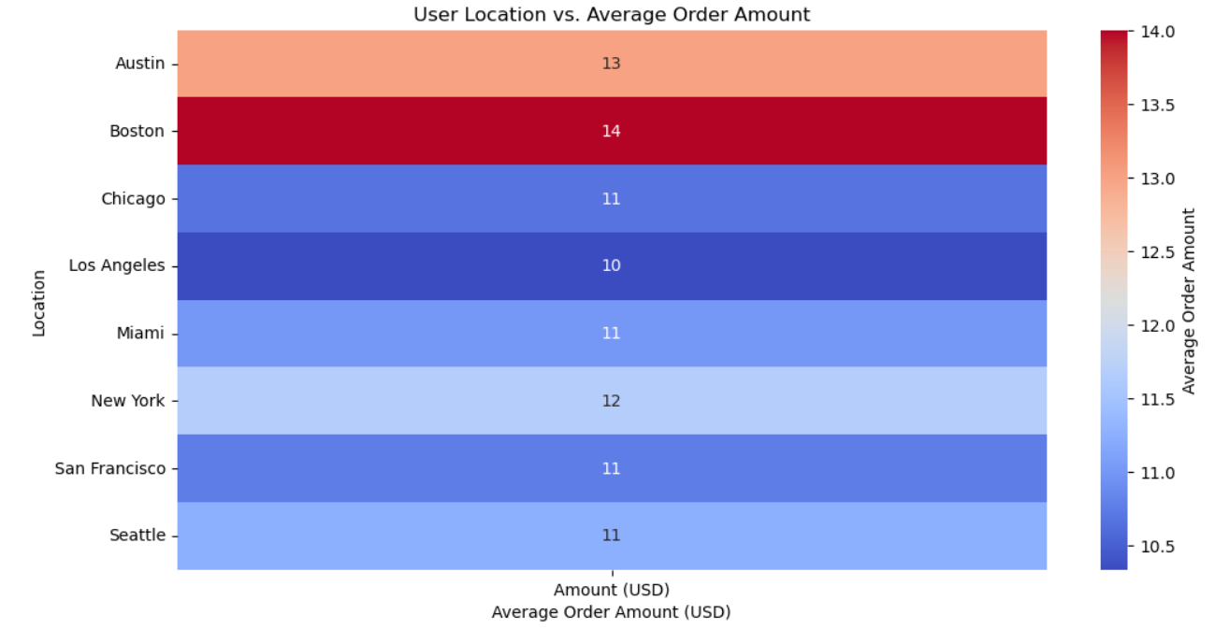
* Launch loyalty programs or bundled offers in underrepresented regions to increase customer retention and engagement

**User-Centric Meal Customization :**

* Longer cooking sessions tend to receive higher ratings. Consider providing more detailed video instructions, live support, or a community forum to keep users engaged during longer sessions.
* Ensure that users are able to easily access real-time assistance if they need help while cooking

**Transformative Recommendations: Leading the Way Forward**

* By focusing on high-engagement user demographics, streamlining order processes, enhancing meal offerings, and strategically expanding to rural markets, Upliance.ai is positioned to elevate user engagement and profitability. A targeted approach to user retention and experience will ensure long-term growth and dominance in an increasingly competitive market.

**Conclusion: A Vision for Market Leadership**

These insights reveal a clear pathway to growth, showcasing opportunities to expand Upliance.ai’s footprint while maximizing both user satisfaction and business revenue. By implementing these data-driven strategies, Upliance.ai can lead the way in the cooking assistance market, ensuring long-term profitability, market expansion, and sustainable user loyalty.